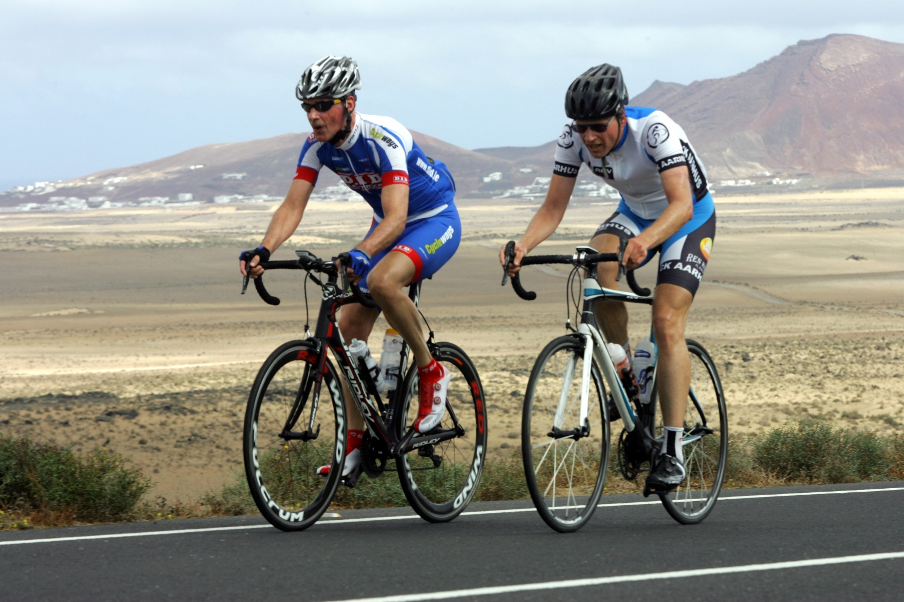

|  |
| --- |
| Dunboyne Cycling Club |
| 2017 Sportive Event Program |
|  |
| There are hundreds of sportive events all over the country / Europe for 2017. I have selected some both home and abroad which will offer a real challenge for all who take part. Full details are available on each of the hosting clubs / event web pages. |
|  |

Dunboyne Cycling Club

2017 Sportive Event Program

# February 2017

19/02/2017 Sunday Donal Crowley Memorial Sportive – Blarney Co. Cork.

# April 2017

1/04/2017 Saturday Stephen Roche Atlantic Challenge, Eninistymon Community Centre, Ennistimon. Co. Clare.

9/04/2017 Sunday Tour of the Foothills Naas CC – M7 Motor Park.

29/04/2017 Saturday Orwell Randonnee, Orwell Wheelers Cycling Club, Lansdowne Old Wesley RFC.

29/04/2017 Saturday Mallorca 312, Mallorca, Spain.

*May 2017*

14/05/2017 Sunday Tour of Lough Derg – North Tipperary Wheelers – The Lakeside Hotel

25/ 05/2017 Saturday Mount Leinster Challenge – Slaney Club GAA Clubhouse.

*June 2017*

04/06/2017 Sunday Gran Fondo, Giro d’Italia NI Titanic Belfast.

11/06/2017 Wicklow 100/ 200

*July 2017*

02/07/2017 Marmotte The Alps, France

16/07/2017 Sunday Etape Du Tour – The Alps, France

30/07/2017 Sunday Meath Heritage Tour - Trim

*August 2017*

Date TBC North Tipperary CC - 30th Anniversary Tour.

13/08/2017 Sunday The Leinster Loop Acorn Road Club St Laurence’s Community Complex

20/08/2017 Sunday The Sean Kelly Tour of Waterford.

27/08/2017 Sunday Pedal the Peaks – Pat Colgan Challenge Tullamore CTC Harriers Athletic Grounds.

*October 2017*

15/10/2017 Sunday Gerry Brannigan Memorial Cycle*.*

*End.*